|  |
| --- |
| **Newsletter**  **Friday 7th January 2022** |



**DATES FOR YOUR DIARY**

Week commencing 24th January 2022 Parents evening

Monday 21st February Half term

Monday 28th February Training day

**You can view the school calendar on the homepage of our website and next year’s term and holiday dates can be found in the parents section of the website as well.**

* **Parents Evenings**

Please note the above date change for parents evening. Further details regarding booking appointments will be sent out next week.

* **Forest school**

Year 5 will be taking part in Forest School this term. Please see the letter sent out separately by email.

* **Church Artwork**

Below is a photograph of the finished artwork that welcomed people to Whixley church on Christmas Eve for the Christingle service. There were a few children from the school who contributed to this.

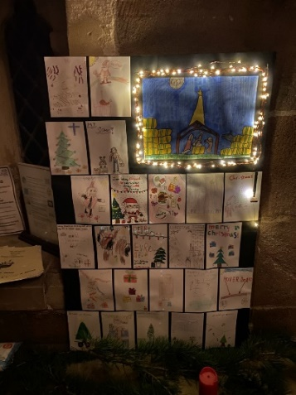

* **Welcome**

We would like to extend a warm welcome to Mrs Brew who is taking up the role of Administrator. Mrs Brew will be working alongside Ms Voakes on a part time basis.

* **Absence reminder**

If your child is unwell, could we please ask that you ring the school by 9.15am to let us know rather than send an email.

* **Covid Update**

Due to an increase in the number of positive Covid cases in our locality it is very important that parents and carers ensure that PCR tests are accessed when children have symptoms, even if they are mild. Prompt action does help to protect everyone in our school family.

The 3 main symptoms remain a fever, a new continuous cough, or a change to/loss of taste or smell. However, other commonly reported symptoms include headache, sore throat, tiredness and cold-like symptoms. Please be aware of these and stay at home and seek testing if you are in any doubt.

* **Morrison’s Good to Grow**

Our school is collecting Morrisons good to grow tokens. From September every £10 you spend in store or online you’ll receive one grow token which you can donate to our school. These tokens will allow us to receive free gardening equipment, seeds and much more. To find out more information please visit <https://www.itsgoodtogrow.co.uk/>

* **BAFTA**

For any queries about before and after school club please email: [s.snowden@mcgprimaryschool.org](mailto:s.snowden@mcgprimaryschool.org)

All BAFTA sessions will be in the school hall.

* **Music Tuition in school**

For children who are interested in applying for music tuition in school, you can find out more information here: <https://www.northyorks.gov.uk/info/information-about-lessons-available-schools>

* **Children walking/cycling alone to school**

Parents of children in Years 5 & 6 may decide that their child is capable of independently walking/cycling to school. If this is the case, then a consent form must be completed for that child and returned to the school office. If your child wishes to ride their bike to school there is a bike rack in the school car park where their bike can be secured during the day. You will need to provide them with a locking device which they can operate themselves.

Please contact the school office if you require a consent form.

**NEWS FROM THE FRIENDS**

Easy fundraising

Please don’t forget that Marton-cum-Grafton Primary School is registered with easyfundraising. So, although we’re unable to get together and hold fundraising events in person at present, we can continue to raise free funds, at no extra cost to you for the school.

When you shop via the easyfundraising website or app, with over 4,100 of your favourite retailers, including John Lewis & Partners, eBay, Booking.com, Amazon and many more, you will raise FREE donations for the school.

If you’re not already registered, please visit our easyfundraising page here:

<https://www.easyfundraising.org.uk/causes/martoncumgraftonps/?utm_campaign=raise-more&utm_content=s-e3>

This will really make a difference to our school! Thank you for your support and thank you to the people who are currently registered on the site and continue to create donations it is very much appreciated.

**“Aspire, Believe and Achieve in a Caring Christian Community”**

Our children will flourish, be safe and valued, in a nurturing Christian community. They will aspire to be the best that they can be; believe in their abilities and gain the courage and confidence to achieve their goals.

Our Christian Vision is lived out through the values of **Kindness, Courage and Respect** and illustrated through the parable of **The Seed and The Sower**

“The seed planted in the good earth represents those who hear the Word, embrace it, and produce a harvest beyond their wildest dreams” Mark 4:20